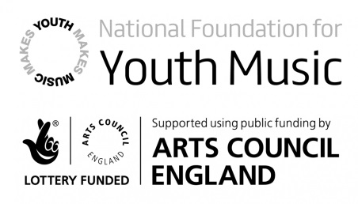
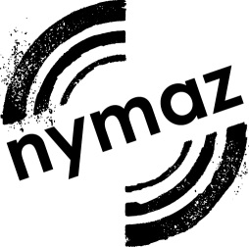

NYMAZ Youth Music Programme 2017-18

Breakthrough Projects Brief

NYMAZ is commissioning two ‘Breakthrough’ projects as part of the NYMAZ Youth Music Programme in 2017-18, funded by The National Foundation for Youth Music.

We are looking for emerging and early career music leaders to deliver music projects for children and young people in North Yorkshire outside of school time.

Practitioners may be employed by an organisation, or working freelance, and should be close to the beginning of their career as a music leader. Practitioners should either be based in, or already working in, North Yorkshire.

Previous Breakthrough projects have had a significant impact on the experience and skills of emerging music leaders in North Yorkshire, as demonstrated by their feedback. For example:

My ability to run and organise successful workshops has blossomed. Prior to this Breakthrough project I had worked mainly in a supporting role as a music leader, but I now feel much more able to plan and lead workshops, especially with other colleagues.

I had the opportunity to devise, plan and deliver a whole project from start to finish for the first time and this has been of great value to my practice as a singing leader.

NYMAZ is looking for project proposals which explore new or interesting ways of tackling issues of rural isolation faced by children and young people aged 5 - 18 in North Yorkshire. As evidenced in NYMAZ’s recent research project on young people, music and rural isolation, Gone in the Air (January 2015), NYMAZ recognises that children and young people living in rural areas face barriers to accessing music provision, and organisations can face challenges in delivering activities. Five of North Yorkshire’s seven Districts are classified as the most sparsely populated ‘Rural-80’ (districts with at least 80% of their population in rural settlements and larger
market towns) on the Rural-Urban Classification scale. We recommend applicants read the Gone in the Air report and consider how their proposal can contribute to the report’s Calls to Action. We use the Big Lottery Fund’s description of rural isolation as ‘feelings of powerlessness and disconnection experienced by individuals or groups as a consequence of living in a rural area’ (Impact on Reducing Rural Isolation, 2011).

In addition to project costs, NYMAZ can also offer the music leader professional development opportunities (CPD) to support their work.

NYMAZ is looking to support 2 projects at a level of £800 each. There is no requirement to contribute match funding. Proposals may be submitted by organisations or individuals. Projects commissioned will be required to comply with NYMAZ’s safeguarding procedures.

Deadline for Proposals: 10am, Monday 13 March 2017

All proposals will receive a response by the end of March.

You can read more about current and recent NYMAZ projects at: http://www.nymaz.org.uk/for-young-people/music-projects

Breakthrough Project Proposal: NYMAZ Youth Music Programme 2017-18

Name of Music Leader:
Name of Organisation (if applicable):
Name of Project:

- Project Overview

- Project aims & outcomes: How does your project seek to tackle issues of rural isolation for children and young people? How does it meet any of the Calls to Action from the NYMAZ Gone in the Air report? Does the project have any other intended outcomes?

- Target groups: Which children and young people will your activities target – what ages and how many? Do these children and young people face any challenging circumstances besides rural isolation?

- Activities: What activities will this project deliver? What new ways will you explore to engage with children and young people?

- Proposed geographic location(s): Where will the activity take place?

- Length of delivery: e.g. 5 x weekly 1-hour after school sessions, 2 x full day workshops etc.

- Proposed dates: activities must take place before 31 March 2018.

- Participant recruitment: How will participants find out about the project?

- Music genre(s): What style(s) of music will be explored in the project?

- Progression opportunities for participants: How will you signpost participants onto other music-making opportunities?

- Professional Development

Professional Development Needs: Please detail any CPD needs already identified, which would help the music leader deliver this project (training, mentoring, shadowing). NYMAZ can provide tailored CPD opportunities.

Please attach a copy of the music leader’s CV, including details of any previous experience of music leading.

- Project Budget
Please outline the proposed budget breakdown: NYMAZ can contribute £800 to each Breakthrough project. Please tell us how this would be spent, broken down into categories such as the following:
- Music leader fees
- Music leader travel expenses
- Venue hire
- Publicity costs (e.g. printing)
- Activity materials
- Participant costs (if applicable, e.g. contribution to travel expenses)
Please also tell us about any likely in kind support (e.g. provision of venues, equipment, materials etc) and any earned income from the project (e.g. ticket sales).

Please submit completed proposals, along with the Music Leader’s CV, to heidi@nymaz.org.uk by 10am, Monday 13 March 2017.
We recommend you discuss your proposed project with NYMAZ before submitting it, please feel free to contact the NYMAZ office on 01904 543382.

