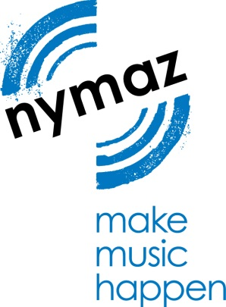

NYMAZ is Seeking a Treasurer

NYMAZ is seeking a committed and willing individual to join our Board as Treasurer, and to support the team of Trustees in their work to champion music, build partnerships and maintain our profile as a leader in youth music development. We are looking for someone who believes in the power of music to positively change lives, however, a background in the arts is not essential. Please note, this position is a voluntary role.

NYMAZ is a youth music charity, championing the transformative potential of music for children and young people in North Yorkshire and across rural England. Working with our trusted partners, we deliver high quality music-making activities to those in challenging circumstances, especially those experiencing rural isolation.
NYMAZ is also committed to strengthening the sector through workforce development, building strategic partnerships and advocating for the benefits of participatory music, and we have become a leading voice across the sector on the issues of rural isolation and digital music education.
In the year following lockdown in March 2020, we provided training and resources to over 4000 professionals and reached almost 30,000 young people through our online programme.
We are actively developing youth voice to empower young people to make decisions about the offer we provide. NYMAZ Board of Trustees currently has two young trustees who lead on advocacy and finance matters, and we have a young producer team who take an active role in programming a variety of NYMAZ events.
NYMAZ is delivering targeted music activities and workforce development to create accessible experiences, where every child can access music-making opportunities, regardless of their circumstances. We are also supporting Music Education Hubs nationally to roll out innovative approaches to increasing access to music through digital technology, via the Connect: Resound project.
NYMAZ receives per annum approximately £300k, and has restricted and unrestricted funds. The National Foundation for Youth Music is our main funder alongside a small number of other significant grant funders such as Paul Hamlyn Foundation and Potterspury Lodge Trust.
We welcome applications from people of all backgrounds, age groups and cultures. We will provide access support for people with disabilities. NYMAZ is an inclusive organisation and we want our Board to reflect the diversity of British society. We will make adjustments to application processes and interviews as required on a case-by-case basis. We also provide ongoing support for the individuals we work with, so if you have particular accessibility needs, please do get in touch and let us know.
About the role
NYMAZ has a dedicated team of Trustees who engage with the Director of NYMAZ to ensure the Board meets high expectations of governance, and that the charity fulfils its mission and meets its aims.
Following the planned departure of our current Treasurer, who is stepping down after fulfilling their term in the role, you will review annual budgets and financial statements, and provide support in presenting the management accounts at quarterly Board meetings. You will form part of the Finance Committee who meet quarterly to scrutinise accounts ahead of Board meetings. You will approve payments and advise on financial matters as required.
We are looking for a forward-thinking individual who believes in the life-changing potential of music to champion the organisation, creating links with a variety of stakeholders, potential partners and supporters.
We currently hold Finance Committee and Board meetings online. This may change to face to face in future, with meetings rotating between York and Harrogate. We are a friendly and inclusive Board and team, supporting and encouraging each other to implement NYMAZ’s objectives.

Role
- Attendance at Finance Committee meetings (approx. four per year), currently held online, where the detailed management accounts are scrutinised, alongside the budgets and other financial matters
- Attendance at quarterly Trustee meetings, including presentation of the management accounts
- Detailed review of the management accounts around four times per annum, including comparisons against budget, and allocation of income and expenditure across the funds and projects of the Charity, and assisting the Director and bookkeeper with these areas. Current accounting software used is Quickbooks (experience of using this software is not required).
- Review of the annual budgets
- Review of the annual statutory financial statements (examined independently – not audited – with the Treasurer liaising with the independent examiner)
- Advice on other financial matters, including remuneration, Charity Commission reporting
- Approval of payment runs
- Liaison with the Charity Director and bookkeeper

Desired experience
- Knowledge of Charity financial reporting, including a detailed working knowledge of the Charities SORP, ideally gained through working in a senior finance capacity at a Charity or through experience of working with not-for-profit clients in a professional services accounting practice
- In particular, understanding how to report expenditure and the requirements of statutory financial statement fund accounting is key
Time commitment
- Meetings – around four hours per quarter
- Other time – no more than one hour in an average month, closer to two hours when considering the year-end financial statements
- Attendance at an annual Away Day with staff and fellow Trustees
- We encourage Trustees to attend NYMAZ events to ensure they have a thorough understanding of the charity and can advocate on our behalf
Please note, this is a voluntary position.

For an informal conversation about the role, please contact Sarah McWatt, Director, at sarah@nymaz.org.uk.
We are an inclusive organisation and can make reasonable adjustments to application processes, interviews, training sessions and other activities on a case-by-case basis. We also provide ongoing support for the individuals we work with, so if you have particular accessibility needs, please do get in touch and let us know.

Application is by letter, or short two-minute video, outlining how you would approach the role and how you feel your skills and expertise would benefit NYMAZ. Please email your letter/video along with a CV to Sarah McWatt at: sarah@nymaz.org.uk

Deadline for applications: 8 October

Further information about NYMAZ

- For further info on NYMAZ’s activities, see: http://www.nymaz.org.uk
- Read NYMAZ’s Annual Review 2018-19 here.
- Charity Overview of NYMAZ and NYMAZ’s latest Annual Trustees’ Report and Accounts on the Charity Commission website.
- Our current projects
- Our professional networks
- Our trustees

What our funders say about NYMAZ:
“It’s quite remarkable to see a year’s worth of activity written down on paper, as it really highlights just how much work NYMAZ has achieved, and with such a small team! Your expertise in online delivery has proven invaluable over the last few months, not just to your participants but to grantholders across Youth Music’s portfolio.”

Louise Henry, Grants Officer, Youth Music.

What our beneficiaries say about NYMAZ:
“My children love the session and I’ve made friends here that I would never have met – I just don’t feel as lonely as I did before.”

“It has helped me develop my musical ability and knowledge a lot. Without it I wouldn’t be half the musician I am today.”
Project participant

“I have always regarded music and music-making as highly valuable but in our area the opportunities had not been great until this project.”
Parent of participant

“The Year 9 boys became part of a spontaneous group improvisation that developed out of a (NYMAZ) interactive concert. It was one of the most magical moments of my teaching experience. Every boy was involved in something musical and very special.”
Teacher

A company limited by guarantee, registered in England and Wales, number 7035894. Registered charity number: 1134287
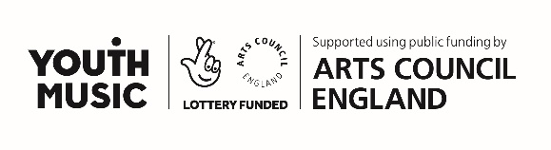
NYMAZ is an equal opportunities employer. We are committed to safeguarding and promoting the welfare of children and expect all staff, partners and volunteers to share this commitment.

